|  |  |  |
| --- | --- | --- |
| Performance Tracker | | |
| Asmt | Grade | Your Grade |
| Zoom | 05 |  |
| 01 | 20 |  |
| 02 | 55 |  |
| 03 | 55 |  |
| Midterm exam | 50 |  |
| Total | 185 |  |
| A: 90-100% B: 80-89% C: 70-79% D: 60-69% F: 0-60%  The course grader provides feedback to your assignments on iLearn. | | |

Midterm Exam Instructions

1. Midterm Exam: **50 points w/ 0 E.C. points**
2. Due Date & Time: **07-12-2020 at 6:00 PM**

What to submit

1. Take-home Exam Report (instructions provided below)

How to Submit and the Rules to Follow

* Submit via iLearn, the Assignment Submission section
* Please follow the exam instructions
* Please follow the Course Policy on Student Conduct and Academic Honesty

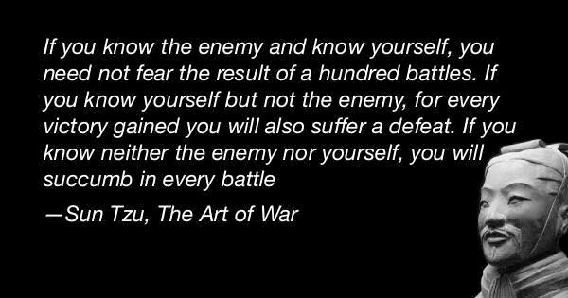About

The goal of this take-home exam is to know what we do not know.

Unfortunately, the campus closure does not allow us to host Midterm exam in person. However, we do not have to give up the goal of the exam which is to have an opportunity to evaluate our knowledge of the topics which we covered.

Let us self-evaluate. Then we will go through the questions and the answers together.

We should be able to find an answer to every exam question from the packages, from the in-class discussions, from our assignments, and from the other course materials. It is important that we take this exam no less seriously than how we take an actual exam. We need to know what we do not know. Learn that again to gain a strong foundation for the second half of the semester. Thank you.

PART A – Take the Exam, **20 points**

* Please allocate 115 quiet minutes to take the exam on page 2 to page 9 as seriously as how you take an actual exam.
* Stop right at minute 116 and grade your answers yourself. Please:

1. Record the date and time when you started and stopped taking the exam.
2. (*Do part B then get back to record*) Your score for each question and your total score out of 100.
3. For each answer, list all the mistakes then explain why, you think, you made the mistakes. If you did not make any mistakes, please document how you could have done better.
4. Include your graded exam in this part.
5. **Problem Solving**: Reflect if you managed the exam time efficiently and if you strategized your test-taking successfully.

PART B – Correct Your Answers, **20 points**

* Please review the related course materials and please write your own code to find a correct answer for each question.
* Please document the correct answers, document how you found the correct answers, and document where you found the materials which support the answers.

PART C – Retake the Exam, **10 points**

* Please do all the steps in part A again.
* Repeat part A to part C again if necessary.
* Please think if the same topics will be tested again in Final exam, what questions we may get.

*It is a good idea to do every step of this assignment thoroughly. We are creating a set of materials which we will use to review for Final exams. And this is also the best way to prepare ourselves to succeed in the second half of the semester. Thank you.*

1. Section, Date and Time: Full Name in Capital Letters | SFSU ID

CSC 220.01, due 07-12-2020 at 6:00 PM

KAYVAUN KHOSHKHOU

920357344

1. Midterm Exam (1 exam, 0 dropped): 100 points __________________________________|__________________
2. To prepare for this exam, please review all the related materials including WEEK 01-06 packages, slides, mock-up exam(s), reading assignments, in-class practices, sample programs posted in the File Manager, and assignments.
3. You do not need to print this exam. No paper. No handwriting. No scanning. Please type up all your answers in the answer space available in the exam. The provided exam will be in Microsoft Word format. Please submit a single PDF via iLearn.
4. All the rules of an actual exam apply to this exam such as: closed books, closed notes, and no communication with anyone except the course instructor. The course instructor will be available on Zoom during the exam time: zoom.ducta.net
5. Please ask all your questions, if any, during the review sessions. Thank you.

Honor Code:

- Please follow the CS Department’s policies: https://cs.sfsu.edu/student-policies  
- Please follow the course’s policies: http://csc220.ducta.net/00-README-StudentConduct_AcademicHonesty.pdf

Part C – 10 Points

**RETAKE**

B.1 - 5 Points

Which of the statement(s) are erroneous and why?

**MidtermExam midtermExam = new Exam(); // A**

**SFSUStaff person = new Person(); // B**

**StackInterface<String> s = new ArrayStack<>(); // C**

The way we work with these statements involves a certain syntax, such that “Test1 object = new Test2();” , this statement is only verified when Test2 **is-a** Test1. In the case of A, MidtermExam is-a Exam, but it doesn’t quite work that well the other way around. The statement is not valid when reading in the format Test1 is-a Test2. Here we have MidtermExam as Test2 and Exam as Test1, hence the invalidity of the statement. The same goes for B, since Person is-a SFSUStaff but SFSUStaff cannot be Person. So my final answer for B.1 is [A & B] are both erroneous.

Corrected using “PersonTester” from Package 01 line 682. **(5/5)**

**FINAL TOTALS:  
  
Part A: 40 POINTS (All correct, Great job!)**

**Part B: 40 POINTS (-20 POINTS from B.6 & B.7 incomplete)**

**TOTAL 80 POINTS**